OrganicERs Newsletter Vol. 9 No. 1
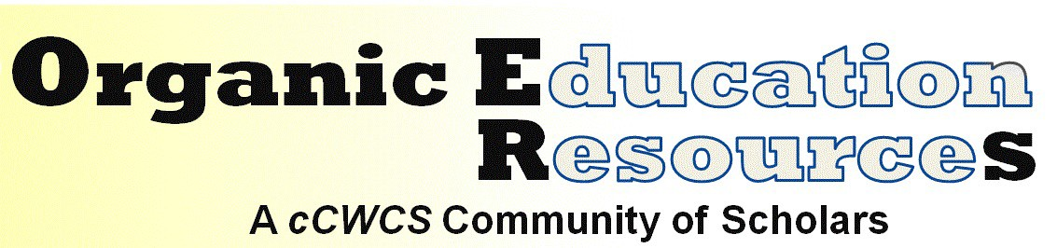

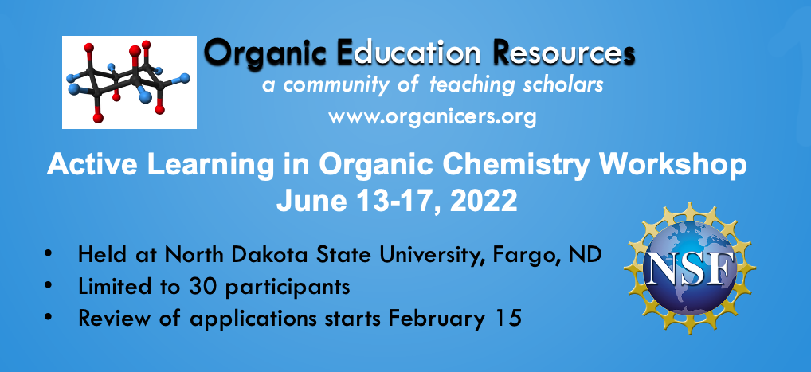
Jennifer Muzyka
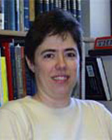
Organic Education Resources (www.organicers.org) invites Organic Chemistry instructors to apply to our Summer ’22 in-person NSF-sponsored workshop (award numbers: DUE2021170, DUE2021175, DUE2021285). Enrollment in this no-cost workshop will be limited to 30 participants to promote collaborative activities and community building for a diverse group of faculty. Experienced members of the OrganicERs Leadership Board will introduce and facilitate implementation of evidence-based instructional methods. (read more)

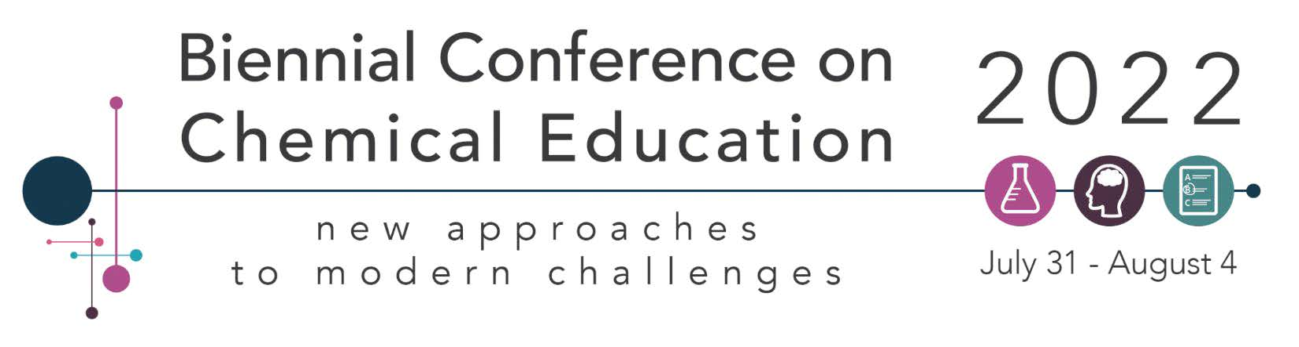
Call for Abstracts: Culturally Relevant and Inclusive Chemistry Curriculum and Pedagogies
Leyte Winfield
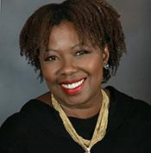
It has been suggested that as the nation seeks to strengthen its stance in STEM, it must leverage the talents of all citizens, including those from minoritized groups. This symposium will focus on curricular efforts that contribute to a more diverse STEM pipeline. Talks will address impactful teaching and learning support strategies that lead to measurable academic success among diverse populations throughout the chemistry curriculum. (read more)

Call for Abstracts: Active Learning in Organic Chemistry
Alexey Leontyev
Multiple studies have shown that the use of active learning pedagogies in the classroom result in positive student learning outcomes in science courses. This symposium includes presentations of organic chemistry faculty who have implemented active learning, broadly defined, in their organic courses. (read more)
Call for Abstracts: Disrupting Grading
Jennifer Muzyka Joshua Ring
Traditional grading systems have been shown to be statistically invalid, unreliable, and oppressive, particularly to students who face systemic inequities. It is time to disrupt grading — to learn different ways to provide evaluation to students. This symposium welcomes anyone who has tried or wants to try a different approach to grading (specifications grading, ungrading, or any alternative to traditional grading). (read more)
Active Learning in Organic Chemistry Workshops
Justin Houseknecht Cathy Welder
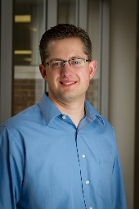 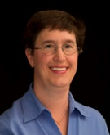JCE Specvial Issue
Two Active Learning in Organic Chemistry workshops have been accepted for the BCCE program. Cathy and Justin will be leading a workshop on Backward Design using principles from Wiggins and McTighe’s book Understanding by Design (2006) and Dee Fink’s Creating Significant Learning Experiences: An Integrated Approach to Designing College Courses (2013). Justin will also be facilitating a workshop about Evidence-Based Collaborative Learning and the Research that Supports It. Neither workshop will be new to those of you that have attended an ALOC workshop lately, but we would appreciate your sharing these opportunities with interested colleagues.

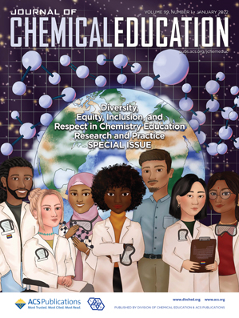
Journal of Chemical Education’s Special Issue on Diversity, Equity, Inclusion, and Respect in Chemistry Education Research and Practice
Leyte Winfield
Chemistry scholars and educators are intentionally creating inclusive curriculum and equitable learning opportunities in response to the inequities in society exposed by the challenges of discrimination and the pandemic over the last few years. This special issue on "Diversity, Equity, Inclusion, and Respect in Chemistry Education Research and Practice" shines a light on discipline-based education research in chemistry that addresses diversity, equity, inclusion, and respect in classrooms, on campuses, and in the broader chemical discipline. (read more)
Welcome to a New Member to the OrganicERs Leadership Board
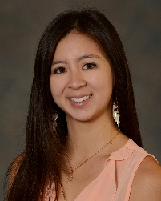
Gidget Tay joins the board to help represent the community college side of chemical education. She participated in the most recent ALOC workshop where she met much of the leadership board. She obtained her Ph.D. in organic chemistry from Scott Rychnovsky at the University of California, Irvine. She was an assistant professor at a small private liberal arts college, helping rebuild the organic chemistry program, before joining Pasadena City College in 2018. She creates educational videos that combine her love of chemistry and dance that she’s coined, “DanceChemistry.” Her current focus is creating a self-paced, personalized course to help students learn the organic chemistry threshold concepts.

Call for Papers: Special Issue on New Visions for Teaching Chemistry Laboratory
You’re invited to contribute to a special issue of the Journal of Chemical Education! This issue is focused on inquiry-based methods of teaching in the laboratory setting. For this issue, inquiry is defined as labs where outcomes aren’t fully known to students or where students are involved with the experimental design. (read more)

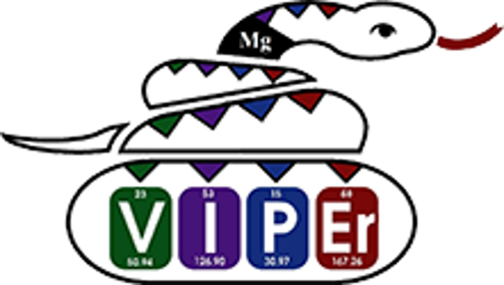
VIPEr Resources
In addition to your organic chemistry courses, do you also teach general chemistry, or organometallic chemistry, or perhaps an integrative lab course? Are you the one the department calls on to fill in when your inorganic chemist is on sabbatical? If any of these are true, the leadership council encourages you to apply for a faculty account on VIPEr, the Virtual Inorganic Pedagogical Electronic Resource (ionicviper.org)! (read more)

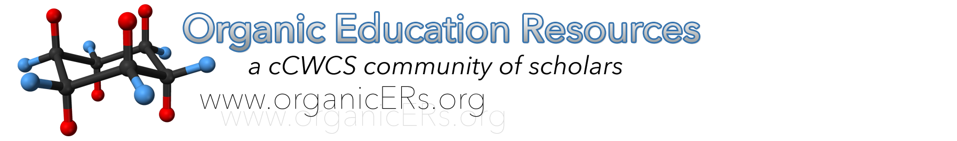
Changes to OrganicERs!
In the summer and fall the OrganicERs website was updated to improve the website and make it more compliant with international standards. Community members will soon have the option to request that their learning objects be peer reviewed. (read more)

