Organic Memory Card Game

This game is designed to practice mechanisms and predict a missing reactant or missing product.

The game consists of three separate decks: a reactant deck (consisting of 50 cards), a reagent deck (consisting of 100 cards) and a product deck (consisting of 50 cards).

These decks are shuffled and all cards from each deck are placed face down in three separate piles:



The person to the left of the shuffler goes first by turning over in either order:

-1 reagent card

-1 reactant or 1 product card

These cards are drawn from either the decks or the memory area. The memory area contains cards that are not stacked, but laid out in a square formation similar to the game *Memory*.

The person then has to draw and/or explain the mechanism while filling in the missing part.

-Assume as many mol equivalents necessary.

-Describe initiation, propagation and termination of radical reactions.

-Use correct terms/rules such as: Markovnikov and Zaitsev, nucleophile and electrophile, etc.

-Some cards have specific words (polymerization, diene, etc.) and must be matched correctly (polymerization with rad. Initiator, diene with dienophile, etc.)

**Scoring is based on the player’s ability to get the major parts of the mechanism and prediction correct while using the correct terms.**

Correct answers award the player with the match of cards as a “trick”.

Incorrect mechanisms/explanations or inability to combine the two cards would require the player to turn the cards face down on the table (memory piles) and end their turn.

Inability example: A player turns over the H - Br reagent card and a product card with no Br’s in the structure. The player would be unable to combine the two cards and so both cards would be turned faced down in the memory area. Another player turns over a reactant card containing an alkene and remembered where the H - Br reagent card was; turns that card over and explains the mechanism by filling in the missing product as an alkane with Br in the structure.

**The goal of this game is to have the most tricks after all possible matches or after a set amount of time.**

Here are two examples:

Example 1:

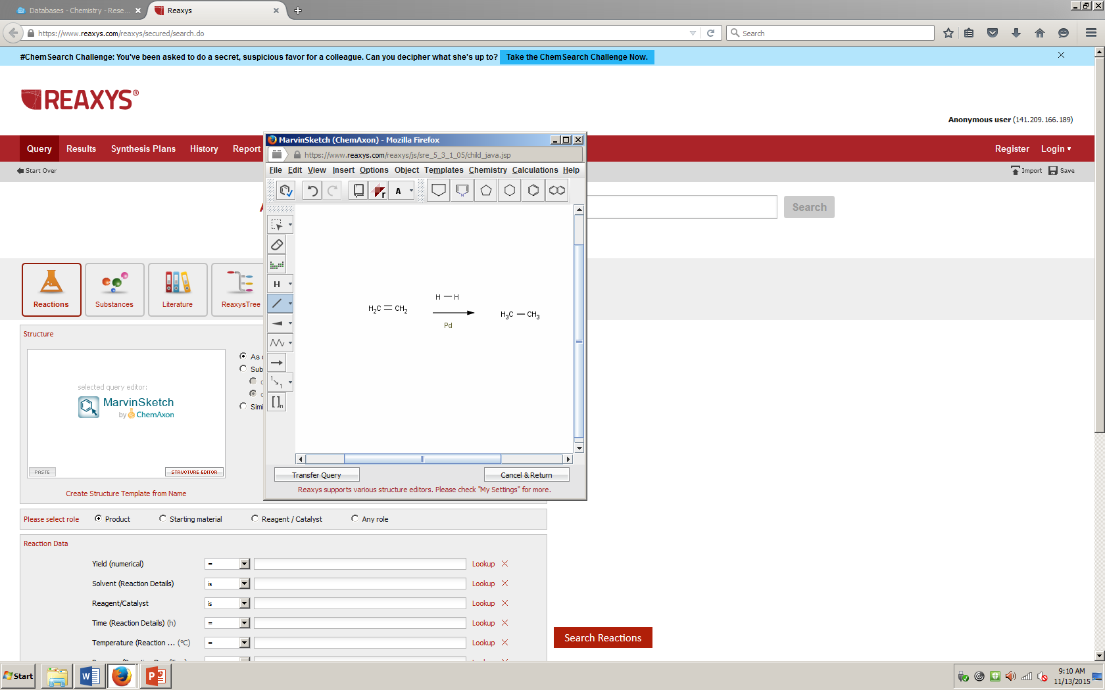

-The reactants are adsorbed on the palladium surface and H2 dissociates.

-An H atom bonds to each C atom on the double bond.

-The alkane is removed from the palladium surface.

The predicted product would be:



Example 2:



-The reactants are adsorbed on the palladium surface and H2 dissociates.

-If one mol equivalent of H-H is assumed, then:

--An H atom bonds to each C atom on the double bond.

--The alkane is removed from the palladium surface.

-If two mols equivalent of H-H is assumed, then:

--An H atom bonds to each C atom on the triple bond.

--The alkene is still attached to the palladium surface.

--Another H atom bonds to each C atom on the double bond.

--The alkane is removed from the palladium surface.

The predicted reactant(s) would be:

