Name ______________________________________________________________ Exam 3

Part 1: Functional Group Review
- Identify the functional groups by matching the given structures with the provided options. Write the letter in the box located under each structure. (6 points)
A. Acetal | F. Anhydride | K. Epoxide | P. Lactam
B. Alcohol | G. Amine | L. Ester | Q. Nitrile
C. Alkene | H. Amide | M. Hemiactetal | R. Ketone
D. Aldehyde | I. Carboxylic acid | N. Imine
E. Alkyne | J. Enamine | O. Lactone

Part II. Reagent Review
- Use the space provided to write or draw the reagent(s) necessary to complete each reaction transformations. (6 points)

A | B | C

- Use the space provided to write or draw the reagents necessary to complete each reaction transformations. (6 points)

A | B | C

- Use the space provided to write or draw the reagents necessary to complete each reaction transformations. (6 points)

A | B | C

- Use the space provided to write or draw the reagents necessary to complete each reaction transformations. (6 points)

A | B | C

Part III: Reaction Review.
- Draw the major organic product(s) formed in the following reaction transformations. (12 points)

- Draw the major organic product(s) formed in the following reaction transformations. (12 points)

Part V: Retrosynthesis.
- Draw the reactants used to produce the following compound by diazonium coupling. (4 points)

- Draw the reactants used to produce the following compound by reductive amination. (4 points)

- Draw the reactants used to produce the following compound by Robinson annulation. (4 points)

Part VI: Spectroscopy Match-up
- Use the following ¹H and ¹³C NMR spectra to determine the correct compound. Please circle your answer.
(6 points)
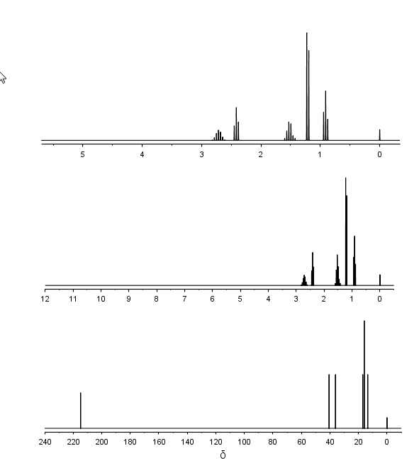
- Use the following ¹H and ¹³C NMR spectra to determine the correct compound. Please circle your answer.
(6 points)
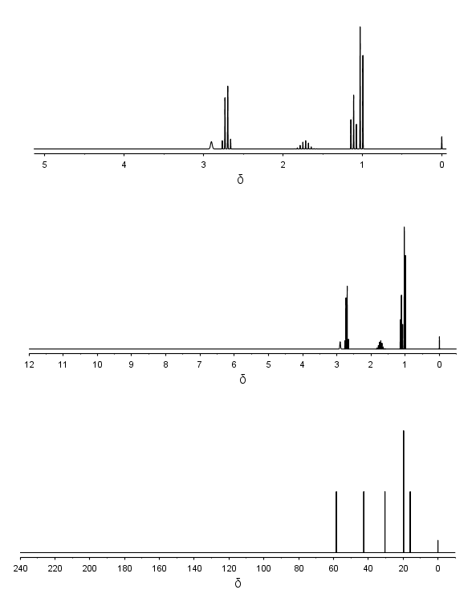

Part VII. Synthesis
- Draw the intermediates of the following stepwise conversion of p-isobutyl benzaldehyde to the analgesic ibuprofen. (11 points)
Ibuprofen

- Draw the intermediates of the following stepwise conversion. (11 points)

