Exam 1: February 11, 2015
Provide organic products, reagents, and reactants as necessary to complete the following reaction schemes. Note that the reactions may not be balanced.
1)

2)

3)

4)

5)

6)

7)

Provide the IUPAC name for the following alcohols.
8)

9)

10)

Synthetic Puzzles: Fill in the empty boxes with the necessary information to complete the following reaction schemes.
11)

12)

Provide the mechanism for the following reactions. Include any lone pairs and correct formal charges on structures.
13)

14)

15) For the following spectrum, label the molecular ion peak and the base peak. Assume that the molecular ion peak is visible in the spectrum for this question. Then write what atom is present in the molecule based on a common mass spectra pattern(s).
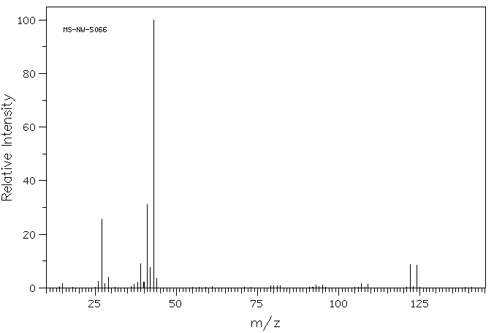
SDBSWeb : http://sdbs.riodb.aist.go.jp (National Institute of Advanced Industrial Science and Technology, 2-10-2015)
Atom present in the molecule:__Br___

16) For the following spectrum of 2-pentanone, label the base peak and the molecular ion peak. Again assume the molecular ion peak is visible. Then, in the space provided, show the ionizati on or fragmentation pathway to produce the peaks at m/z = 86 and m/z = 57.
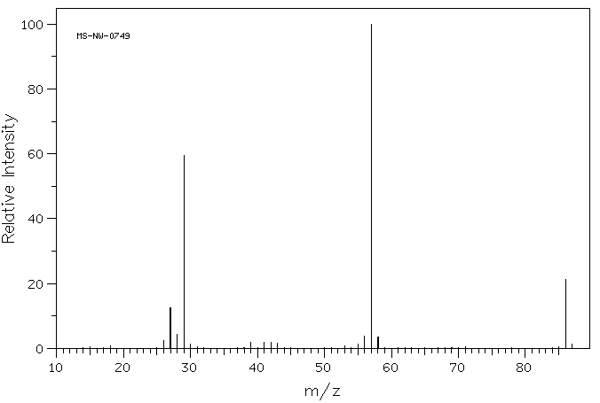
SDBSWeb : http://sdbs.riodb.aist.go.jp (National Institute of Advanced Industrial Science and Technology, 2-10-2015)
Ionization

Fragmentation

Grading Rubric for Exam 1 Spring 2015 (54 points total)

Questions 1-7 (14 points)
2 points each
Question 2: Missing H on O (-1 point)
Question 6: Extra H (-1 point)
Question 7: Reverse order (-1 point)
Na instead of Li (-1/2 point)
Questions 8-10 (6 points)
2 points each
Wrong base name (-1 point)
Errors involving commas or hyphens or parenthesis (-1/2 point each)
Wrong numbering (-1 point)
Wrong alphabetizing (-1 point)
Wrong substituent name (-1 point)
Z vs. E (-1 point)
Note: If the wrong base chain was chosen, apply the last five penalty conditions according to the new base chain.
Question 11 (4 points)
2 points per structure
Question 12 (4 points)
2 points for the reagents on the first reaction
(-1 point for oxymercuration/demercuration)
2 points for the product of the second reaction
Question 13 (10 points)
1 point per arrow (6 points)
2 points for each intermediate (4 points)
Incorrect formal charge (-1 point per structure)
Incorrect lone pairs (-1 point per structure)
Question 14 (6 points)
1 point per arrow (4 points)
2 points for the intermediate (2 points)
Incorrect formal charge (-1 point per structure)
Incorrect lone pairs (-1 point per structure)
Question 15 (4 points)
Correctly labeled base peak (1 point)
Correctly labeled molecular ion peak (1 point)
Correct atom (2 points)
Question 16 (6 points)
Correctly labeled base peak (1 point)
Correctly labeled molecular ion peak (1 point)
Correct ionization pathway shown (2 points)
Correct fragmentation pathway shown (2 points)

Notes on Question 16

Key Conceptual Features on Ionization and Fragmentation Pathways
1) The correct radical cations (from ionization) and fragment cations (from fragmentation) should be shown.
Single instead of triple bond (-1 point)
Missing radical cation on ionization (-1/2 point)
Charge on wrong atom (-1/2 point)
Missing charge (-1/2 point)
Cation but no radical (-1/2 point)
Only has math for the ion (-1/2 points)
2) A pathway is shown which implies a reactant, arrow and product.
Ionization pathway not shown (-1 point)
Missing fragmentation entirely (-2 points)
Wrong fragmentation pathway (gives wrong fragments) (-2 points)
Fragment in wrong direction (-1 point)
Fragmentation/ Ionization not shown, just structure (-1 point)
Fragment symbol is pointing in the wrong direction for the fragments shown which are correct (-1/2 point)
Missing arrow or equal sign(-1/2 point)
Non-essential components (electrons and radicals) for explaining peaks in spectrum.
2e on left ( - 0 points)
Missing ethyl radical on right (-0 points)
Missing 2e on right (-0 points)

