Last Name, First Name Student Number Section

Organic Chemistry II

Instructor: Dr. Weldegirma

Spring 2015

Exam 2

February 27, 2015
Instructions:

- READ AND FOLLOW ALL OF THESE INSTRUCTIONS.
- WRITE YOUR NAME AND SECTION NUMBER ON TOP OF THIS PAGE. FAILING TO DO SO MAY DELAY GRADING YOUR EXAM.
- Sit in alternate seats: make sure there is nobody in the seat on either side of you.
- You may have pencils and erasers in your possession-any other materials in your proximity will be removed.
- Make sure your exam has, including this cover page, 10 pages.
- Do not separate pages from the exam – leave all pages stapled together.
- This is a 90-minute exam. Stop all work on your exam when the end of the exam is announced.
- Answer all questions correctly.

Good Luck

Problem and Overall Score
- /10 4. /10 7. /10
- /10 5. /10 8. /10
- /10 6. /30

Total: /100

- (10 pts) Multiple Choice. Circle the correct answer in the following questions.

i. Which compound has the slowest rate toward an electrophilic aromatic substitution reaction?

ii. Which compound has NO basic nitrogen?

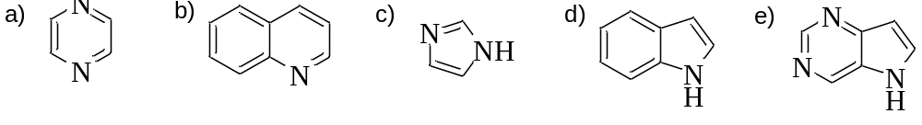
iii. Which phenol is the least acidic?

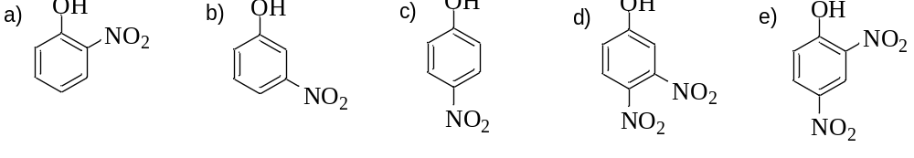

iv. Which compound shows no reaction with chloromethane and aluminum chloride?

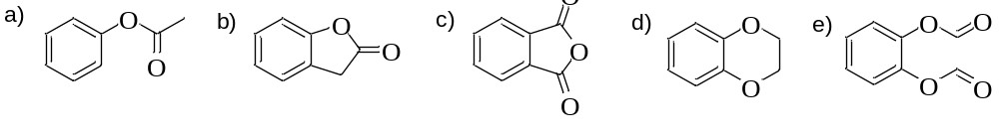

v. Which undergoes nucleophilic aromatic substitution rapidly with a hydroxide ion in normal conditions?

a) benzene b) chlorobenzene c) 1-chloro-4-nitrobenzene
d) p-chlorotoluene e) 1-chloro-2,4,6-trinitrobenzene

vi. The structure of the intermediate for the following reaction is:

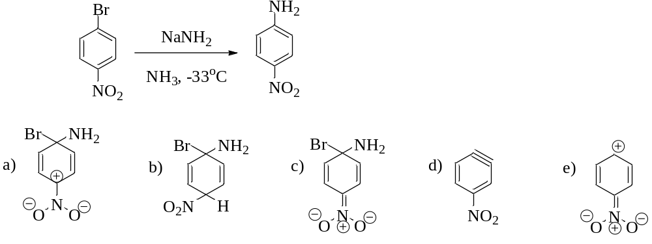

vii. Which set of reagents will best accomplish this transformation?

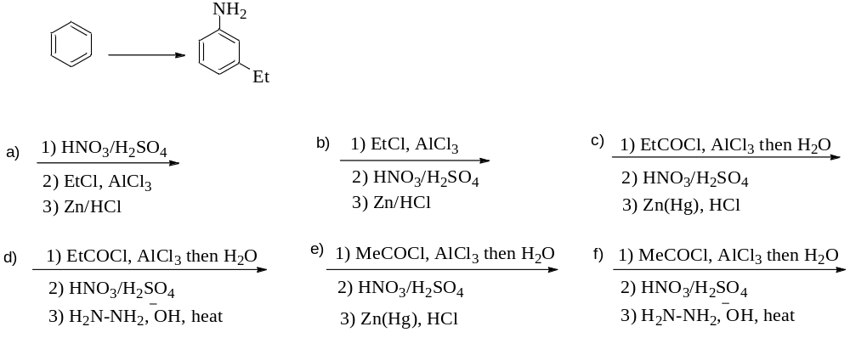

viii. Among the alcohols listed below, the alcohol that most readily loses water in the presence of an acid is:

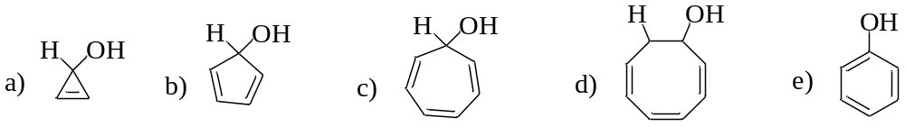

ix. Identify the fastest reaction.

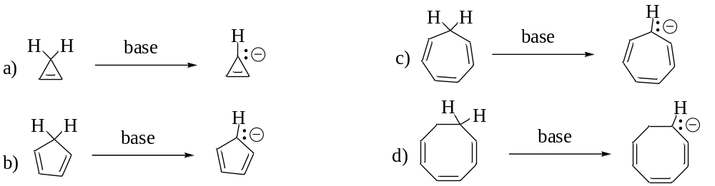

x. Which one is the most stable ion?

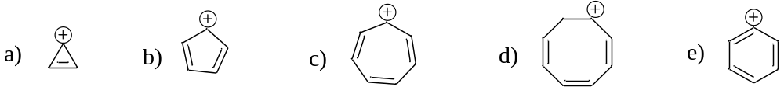

2. (10 pts) Synthesis…

Direct bromination of the starting aromatic compound (shown in the reaction below) produces the para product as the major product while the desired ortho product is the minor product.

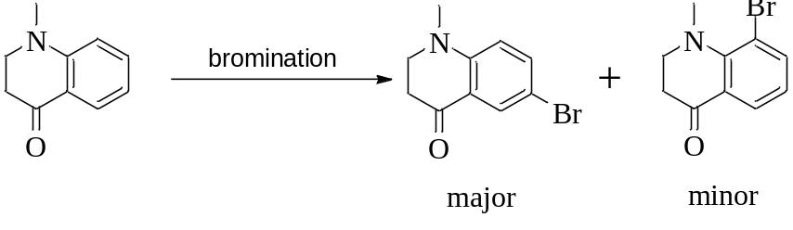

Provide an acceptable synthetic pathway for the synthesis of the ortho product as the major product. Please include all the necessary reagents to earn the full credit.

3. (10 pts) Nomenclature…

A. (6 pts) Provide a systematic name for each of the following compounds.

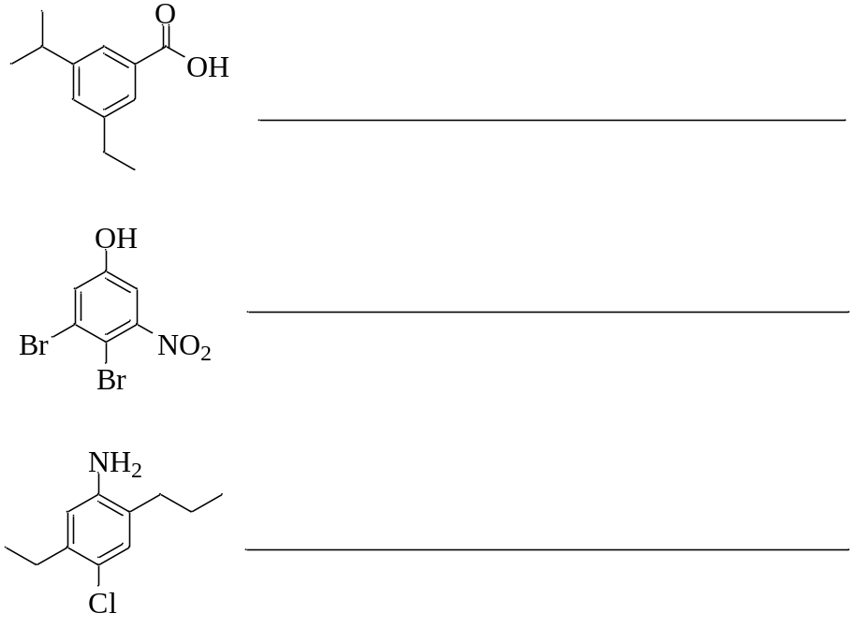

B. (4 pts) Draw the correct structure for each of the following compounds.

[10]annulene

4-(dichloromethyl)-2-nitrobenzenesulfonic acid

4. (10 pts) Classify each of the following molecules and ions as aromatic, antiaromatic or nonaromatic.
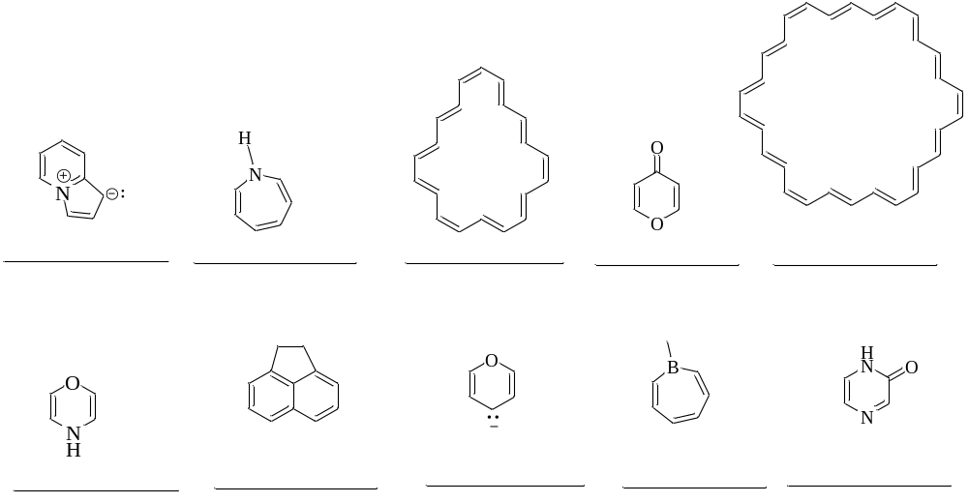
5. (10 pts) Using any necessary reagents, show how you would accomplish the following transformations.

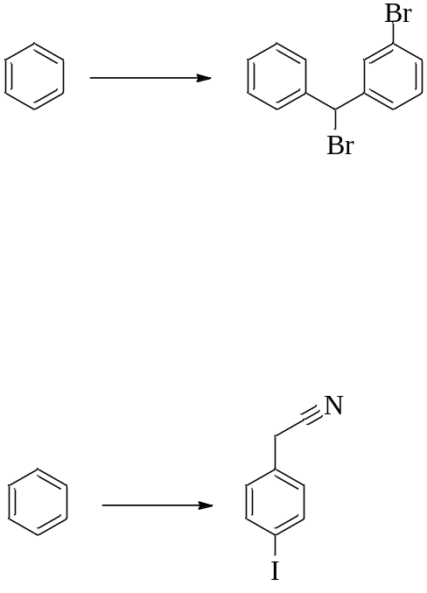

6. (30 pts) Predict the major product(s) for each of the following reactions paying attention to the regio- and stereochemistry. If there is no reaction, write just “No Reaction”.

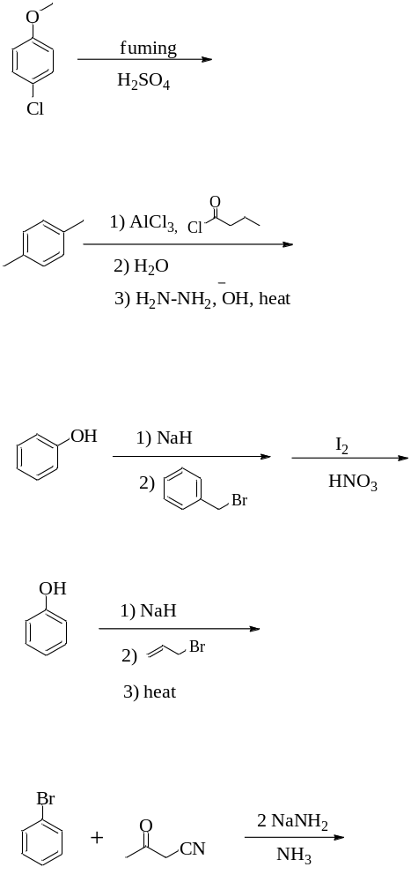

6. Predict major product (Contd…)

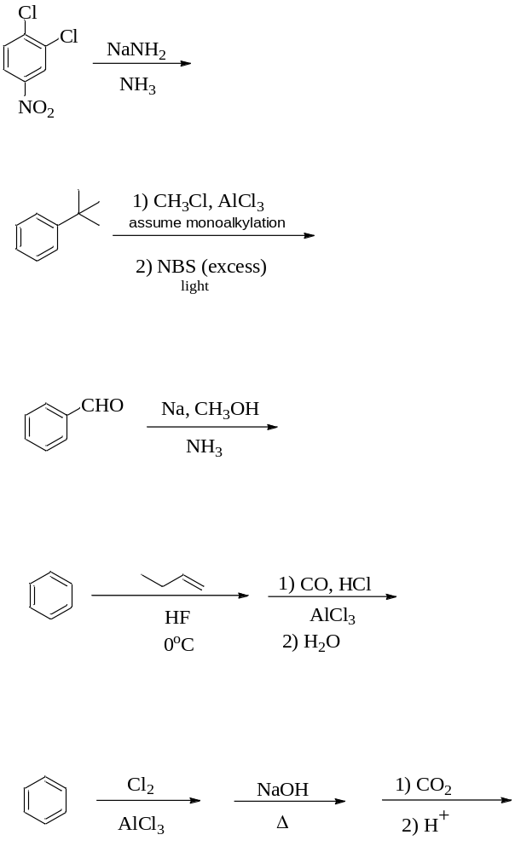

7. (10 pts) Consider the following reaction:

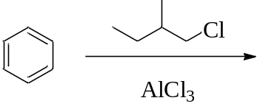

a) (4 pts) Draw the structure of the major product.

b) (6 pts) Illustrate the mechanism. Indicate all electron movements and the structures of all intermediates (structure of one sigma complex is enough) for full credits.

8. (10 pts) Synthesis…The following two synthetic pathways do NOT produce the indicated products. Identify the defect in each synthesis pathway and provide an acceptable synthetic pathway for the synthesis of each of the products.



