Exercise 13-3: NMR Questions
Match the NMR spectra below with the correct structure.
NMRs are from https://www2.chemistry.msu.edu/faculty/reusch/virttxtjml/spectrpy/nmr/nmr1.htm
- 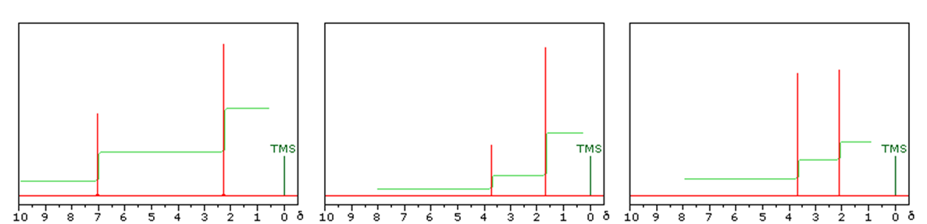

2.
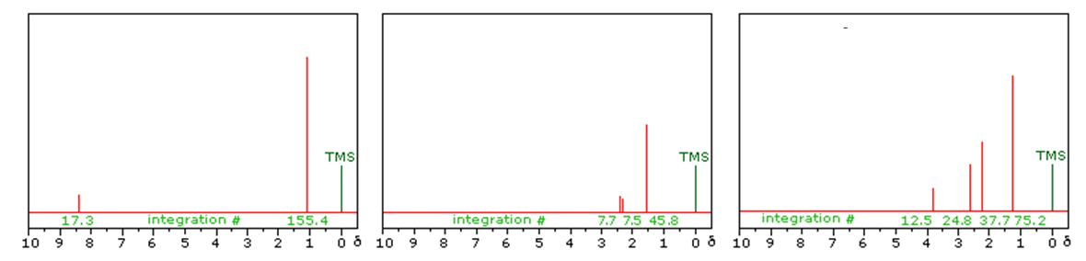
3.
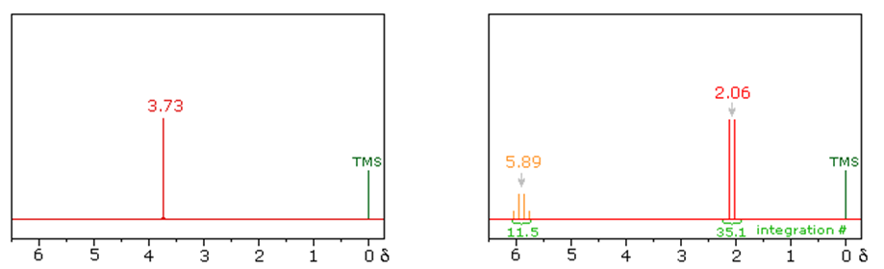

4.

NMRs generated from ChemBioDrawUltra 13.0

